

**Module Code & Module Title**

**CC4002NI Information Systems**

**Assessment Weightage & Type**

**30% Individual Coursework**

**Year and Semester**

**2018-19 Autumn**

**Student Name: Sodip Bikram Thapa**

**College ID: NP01CP4A180059**

**Assignment Due Date: 10th May 2019**

**Assignment Submission Date: 9th May 2019**

*I confirm that I understand my coursework needs to be submitted online via Google Classroom under the relevant module page before the deadline in order for my assignment to be accepted and marked. I am fully aware that late submissions will be treated as non-submission and a marks of zero will be awarded.*

**Table of Contents**

Introduction 1

Discussion and Analysis 2

Testing 11

• Test 1 11

• Test 2 12

• Test 3 14

• Test 4 15

• Test 5 16

Conclusion 18

References 19

**Table of Figures**

Figure 1: Wireframe (Welcome Section) 2

Figure 2: Wireframe (Explore Section) 3

Figure 3: Wireframe (Blogs Section) 3

Figure 4: Wireframe (About Section) 4

Figure 5: Wireframe (Contact Section) 4

Figure 6: Wireframe (Blog Page) 5

Figure 7: Wireframe (Research Page) 5

Figure 8: Welcome Section (Index Page) 7

Figure 9: Explore Section (Index Page) 8

Figure 10: About Section (Index Page) 8

Figure 11: Research Page 9

Figure 12: Contact Section (Index Page) 9

Figure 13: Blog Page(s) 10

Figure 14: Test 1 11

Figure 15: Test 1 12

Figure 16: Test 2 13

Figure 17: Test 2 13

Figure 18: Test 3 14

Figure 19: Test 3 14

Figure 20: Test 4 15

Figure 21: Test 4 16

Figure 22: Test 5 16

Figure 23: Test 5 17

**Table of Tables**

Table 1: Test 1 11

Table 2: Test 2 12

Table 3: Test 3 14

Table 4: Test 4 15

Table 5: Test 5 16

# Introduction

The Internet and the World Wide Web both have become an integral part of the modern society. We cannot even go one day without using them at least once. The Internet and the World Wide Web connect people from around the world. We can share our ideas and opinions, buy and sell different products and even start our own businesses. These two technologies have made our lives easier. Therefore, it is important for us as IT students to understand the workings of these two technologies. For that, we must first understand how websites work and how we can make one, which is the aim of this coursework.

For this coursework, we must design as well as develop our portfolio website by ourselves. The website must include five pages including our CV and blogs that explain the effects of technology on our lives. The website must also contain a research section where we must compare our website to the websites that it based upon or inspired from. We must use HTML, CSS and JavaScript to make the website.

The main objectives of this coursework is to help us understand the basics of Internet Technologies and develop competency in developing a website with proper tools and methods. It will also help us to become familiar with the current trends in the field of web development and provide an experience to understand what it takes to develop a website in real life. Therefore, it is important for us to take this coursework seriously and use it as a valuable learning experience.

# Discussion and Analysis

For designing the website for this coursework, I researched about the current trends in web design modern web principles. After that, I searched for websites that followed those trends and principles to decide how I would design my website. Finally, I decided I would make my website single paged. I have tried to achieve a minimalistic look and feel for my website, as it seems to be the current trend. I have included the websites, which my website is based upon in the research page of the website. There, I have compared the similarities between my website and those websites.

After deciding upon the look and feel of the website, I drew up the wireframes so it would be easier for me code. For the wireframes, I have used Balsamiq Mockup 3. The wireframes have been included below:

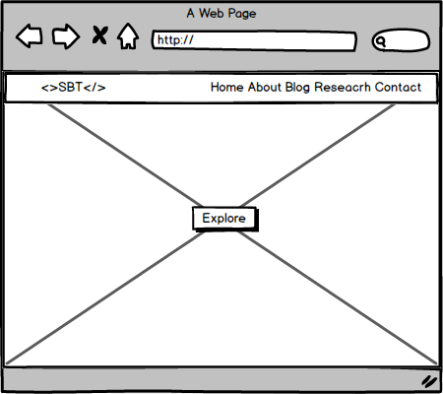

Figure 1: Wireframe (Welcome Section)

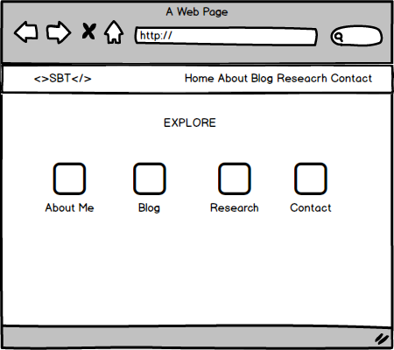

Figure 2: Wireframe (Explore Section)

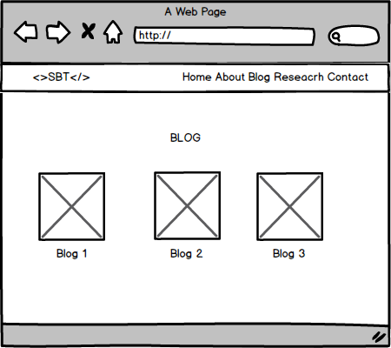

Figure 3: Wireframe (Blogs Section)

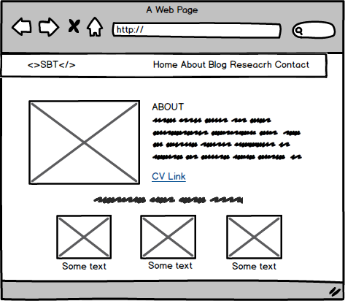

Figure 4: Wireframe (About Section)

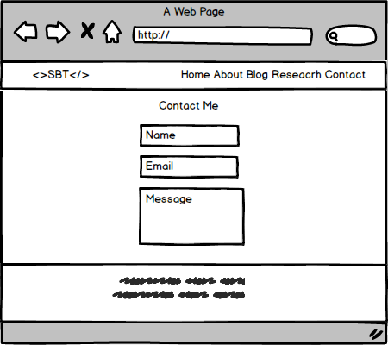

Figure 5: Wireframe (Contact Section)

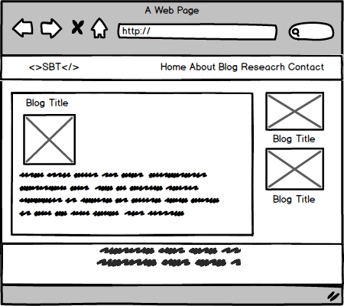

Figure 6: Wireframe (Blog Page)

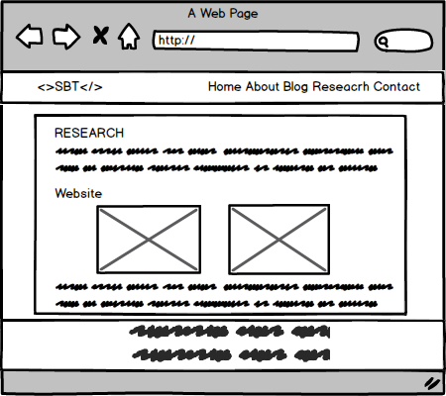

Figure 7: Wireframe (Research Page)

After designing the wireframes for the website, I started coding the HTML parts first. The HTML code was much easier to write, as it is a single paged website so I had to write lesser code compared to multi-paged website. Then, I started writing the CSS code. I have used a single external CSS sheet for elements that have been included in all the pages of the website for e.g. the navigation bar. I have used internal CSS when an element is exclusive to only one page and inline CSS for special cases. Finally, after finishing both the HTML and CSS parts I started with JavaScript. I have used JavaScript for form validation and for designing the dynamic aspects of the website. In order to properly understand the topics, which I found to be difficult I used the W3Schools website. I followed the instructions provided there and used the examples as reference for such topics. I also watched videos on YouTube about designing portfolio websites based on my skillset and knowledge that I possessed at the time I worked on this coursework.

**HTML**

HTML stands for Hyper Text Markup Language. It is used to describe the structure of a web page using markup. Tags represent HTML elements. Browers use these tags to build the content of web pages. (w3schools.com, 2019)

**CSS**

CSS stands for Cascading Style Sheets. It is a styling language that is used to describe the look of HTML elements. The browser then displays the elements accordingly. (w3schools, 2019)

**JavaScript**

JavaScript is a high level typed programming language. It is used in both the frontend and backend. In the frontend, it is used program the behavior of a webpage. (w3schools, 2019)

I have used both the flexbox layout and the grid layout of CSS to design the website’s layout. I have used the flexbox layout in multiple sections but have only used the grid layout in the Research page for we weren’t introduced to the concept in our lecture classes so I didn’t have enough time to learn everything about it. I used the stock image sites Pexels and Unplash to get images that I could use for my website. I used Notepad++ as my text editor to write code as that is what our teacher had advised us to do. We were advised not use any advanced text editors as it would have stopped us from being familiar with boilerplate code. Finally, after completing the website, I wrote this report as a form of documentation. The screenshots of the different sections of website after its completion have been included below:

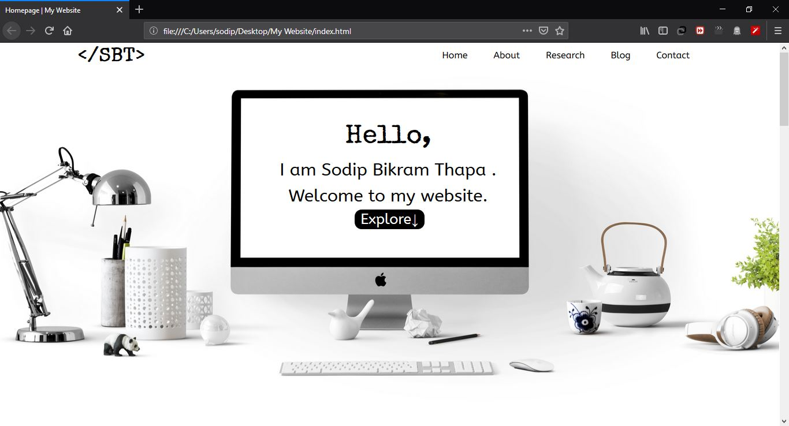

Figure 8: Welcome Section (Index Page)

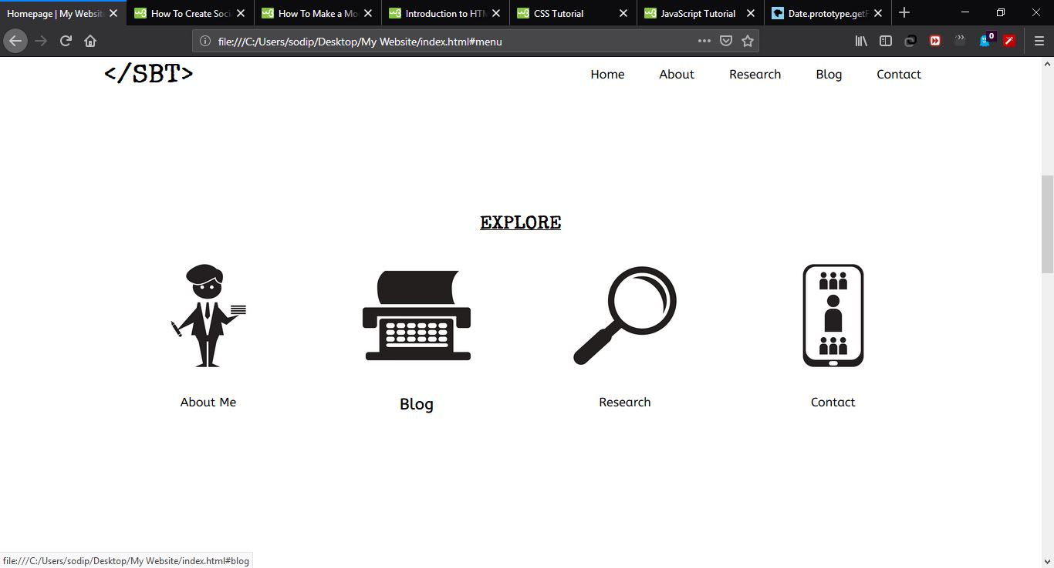

Figure 9: Explore Section (Index Page)

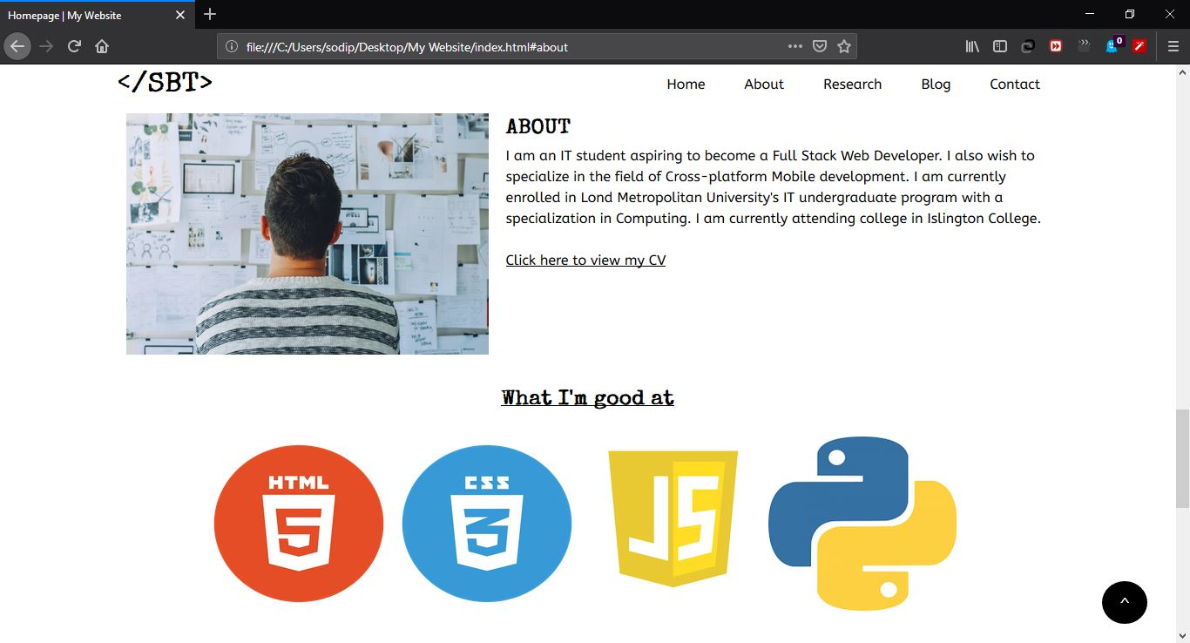

Figure 10: About Section (Index Page)

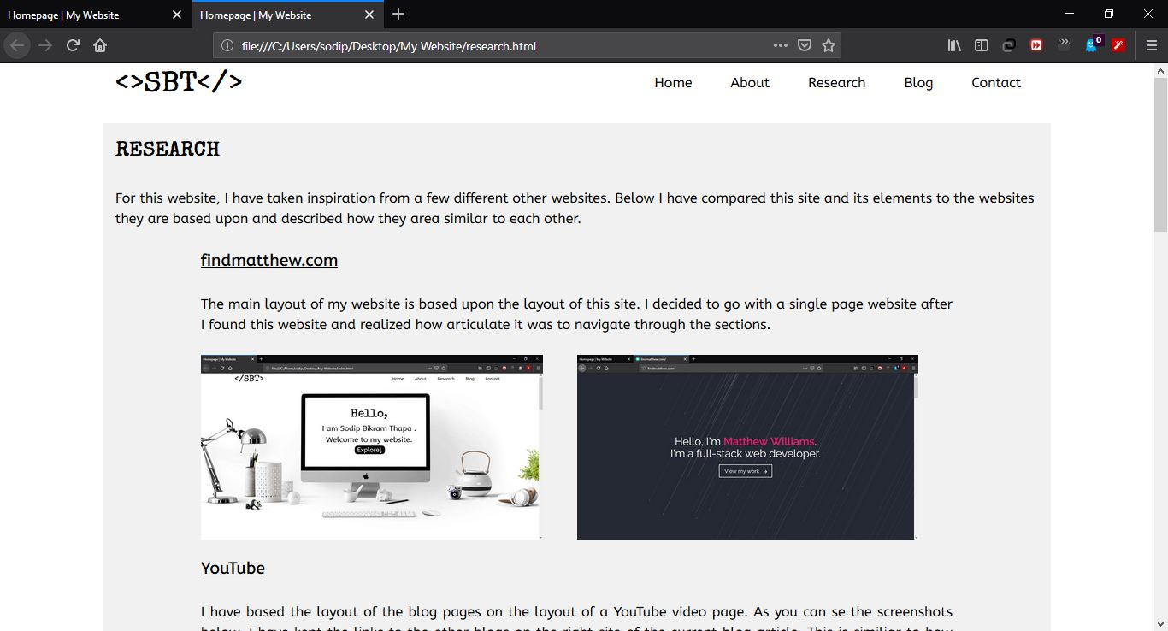

Figure 11: Research Page

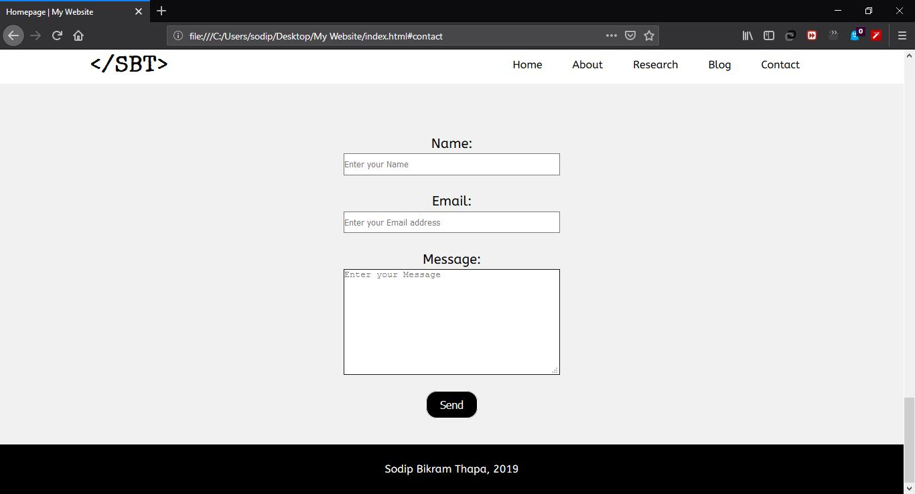

Figure 12: Contact Section (Index Page)

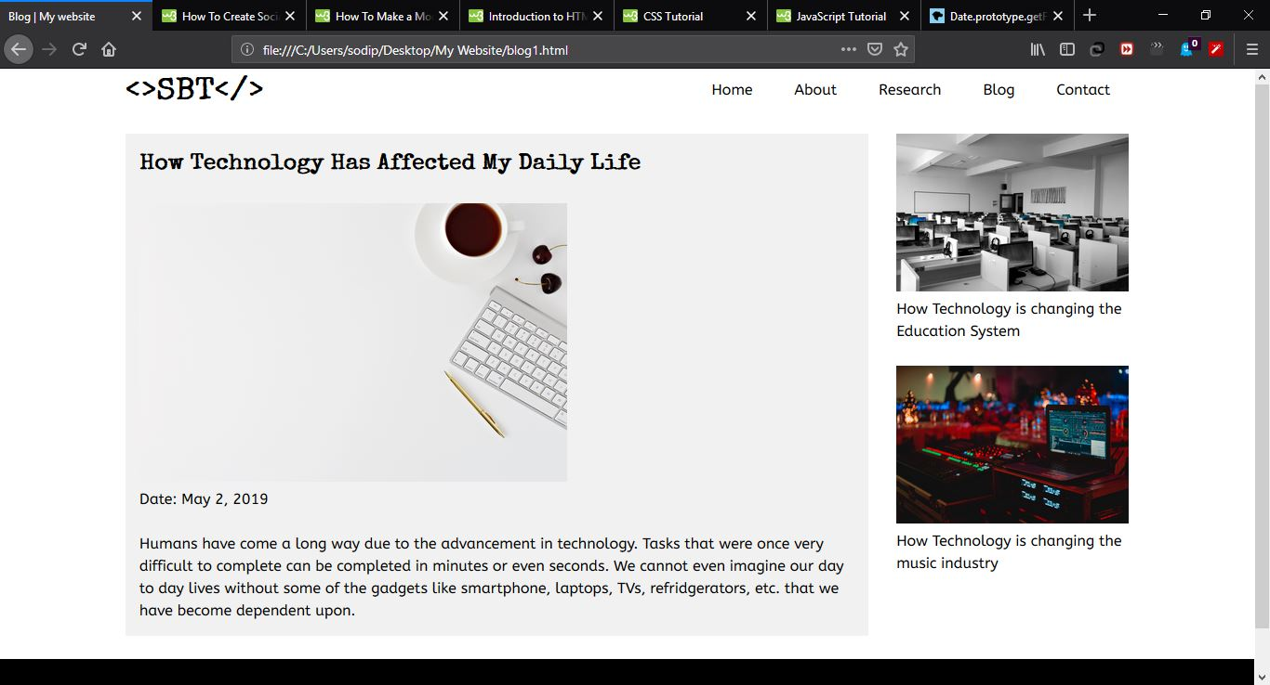

Figure 13: Blog Page(s)

# Testing

In order to check the proper functioning of the website, the following tests were done:

## Test 1

Table 1: Test 1

|  |  |
| --- | --- |
| Test No. | 1 |
| Action | Click explore button |
| Expected Output | The page smoothly scrolls down to the explore section |
| Actual Output | The page smoothly scrolls down to the explore section |
| Test Result | Pass |

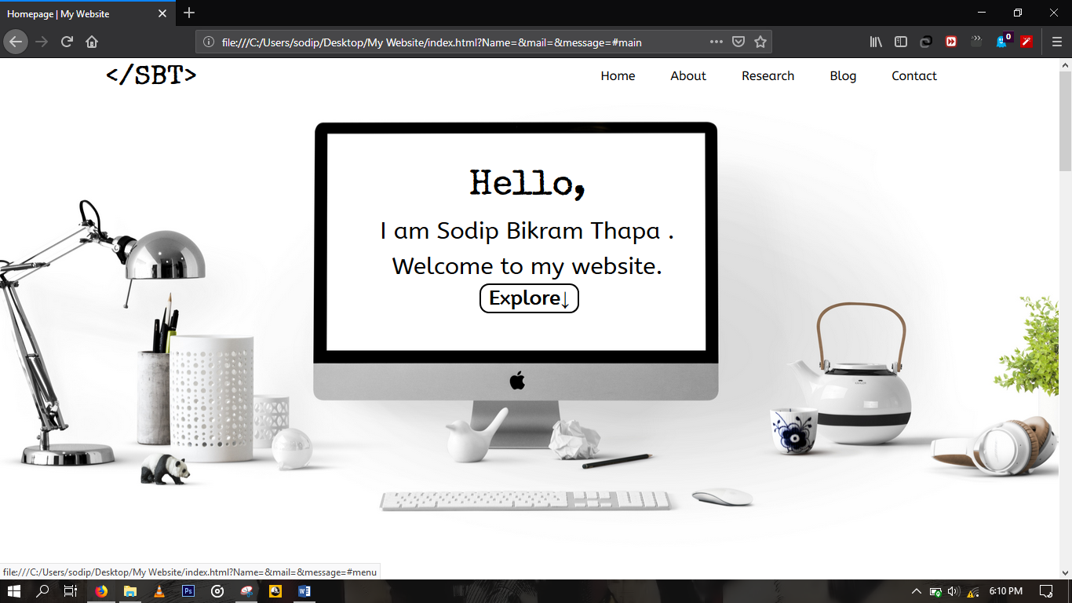

Figure 14: Test 1

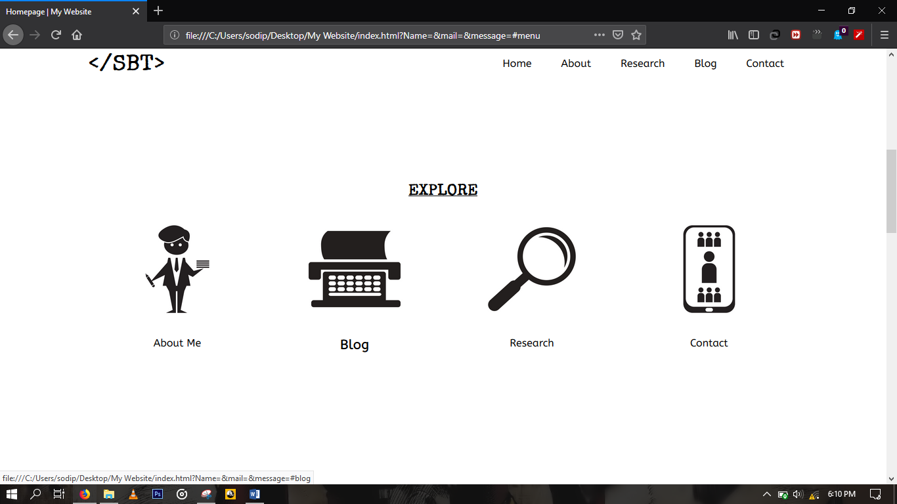

Figure 15: Test 1

## Test 2

Table 2: Test 2

|  |  |
| --- | --- |
| Test No. | 2 |
| Action | Proper data is submitted in the form |
| Expected Output | Success message is displayed |
| Actual Output | Success message is displayed |
| Test Result | Pass |

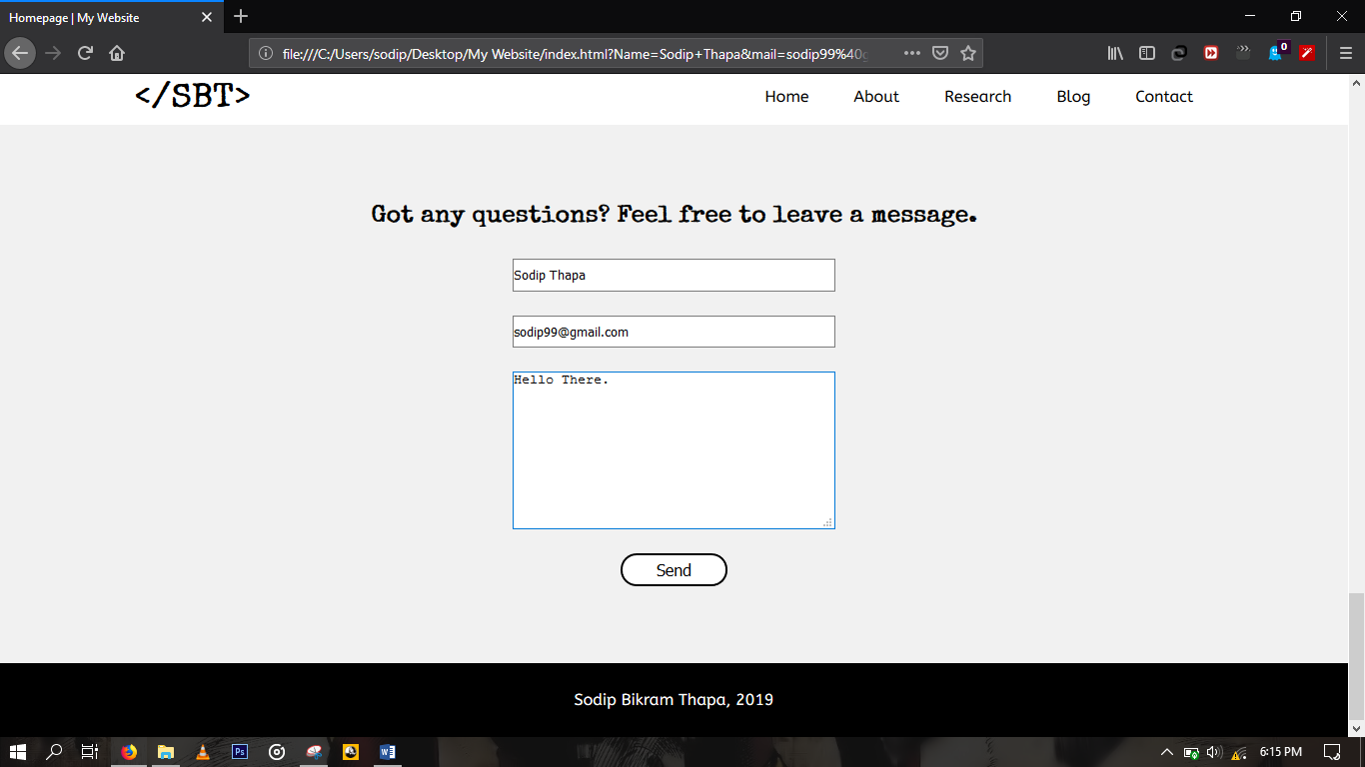

Figure 16: Test 2

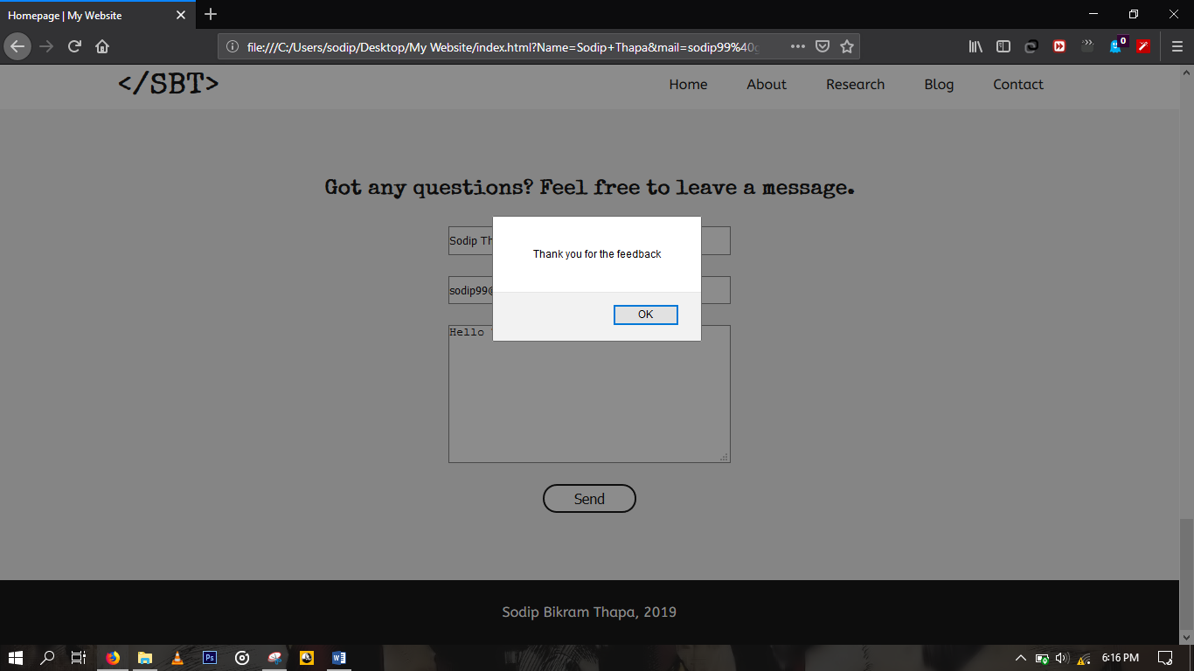

Figure 17: Test 2

## Test 3

Table 3: Test 3

|  |  |
| --- | --- |
| Test No. | 3 |
| Action | Improper data is submitted in the form |
| Expected Output | Error message is displayed |
| Actual Output | Error message is displayed |
| Test Result | Pass |

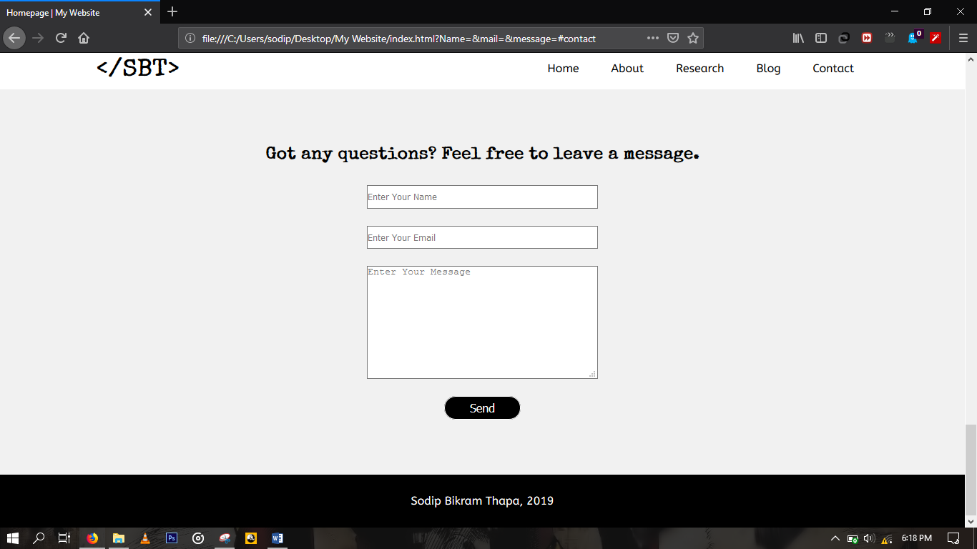

Figure 18: Test 3

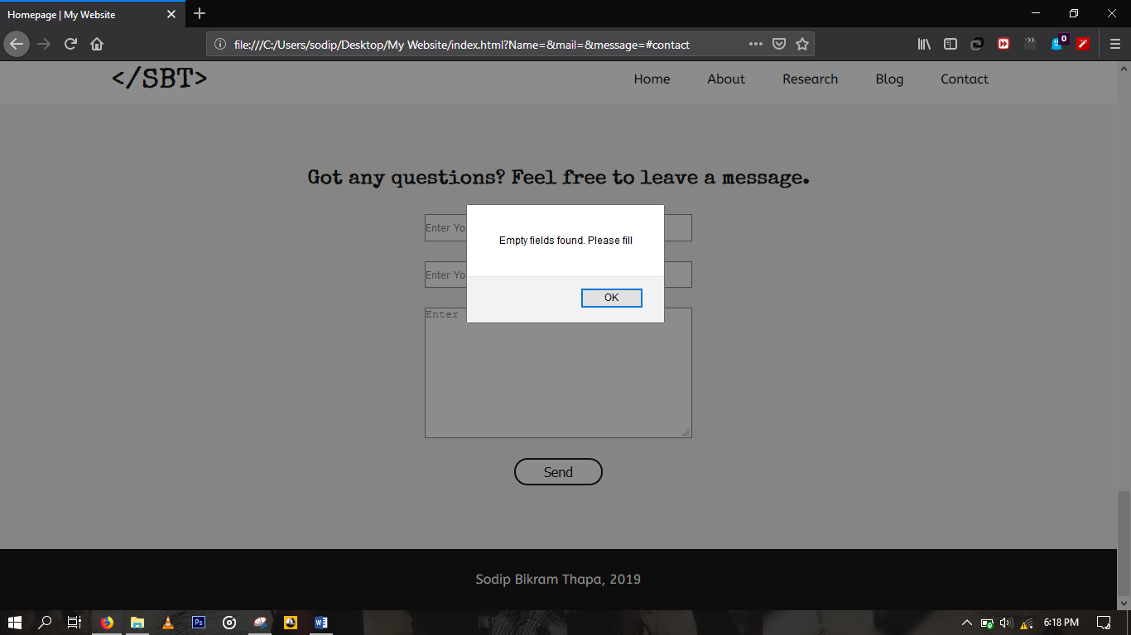

Figure 19: Test 3

## Test 4

Table 4: Test 4

|  |  |
| --- | --- |
| Test No. | 4 |
| Action | The back to top button is clicked |
| Expected Output | The page smoothly scrolls back to the top |
| Actual Output | The page smoothly scrolls back to the top |
| Test Result | Pass |

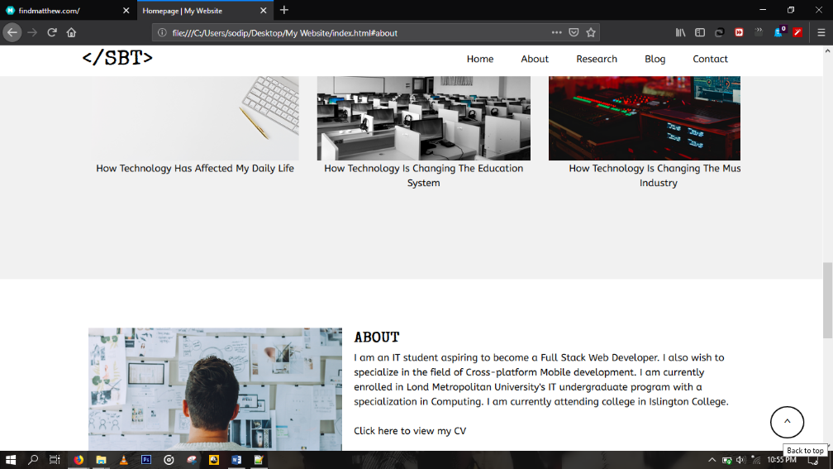

Figure 20: Test 4

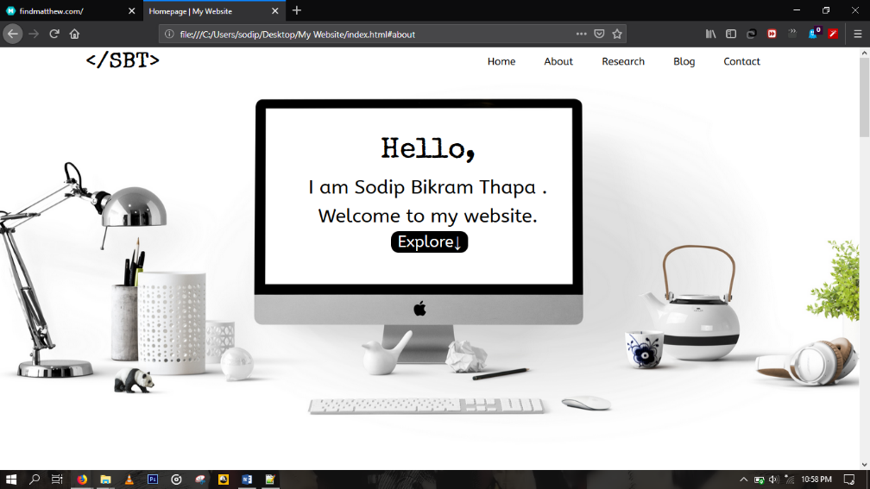

Figure 21: Test 4

## Test 5

Table 5: Test 5

|  |  |
| --- | --- |
| Test No. | 5 |
| Action | The link for a website in the research page is opened |
| Expected Output | The link is opens in a new tab |
| Actual Output | The link is opens in a new tab |
| Test Result | Pass |

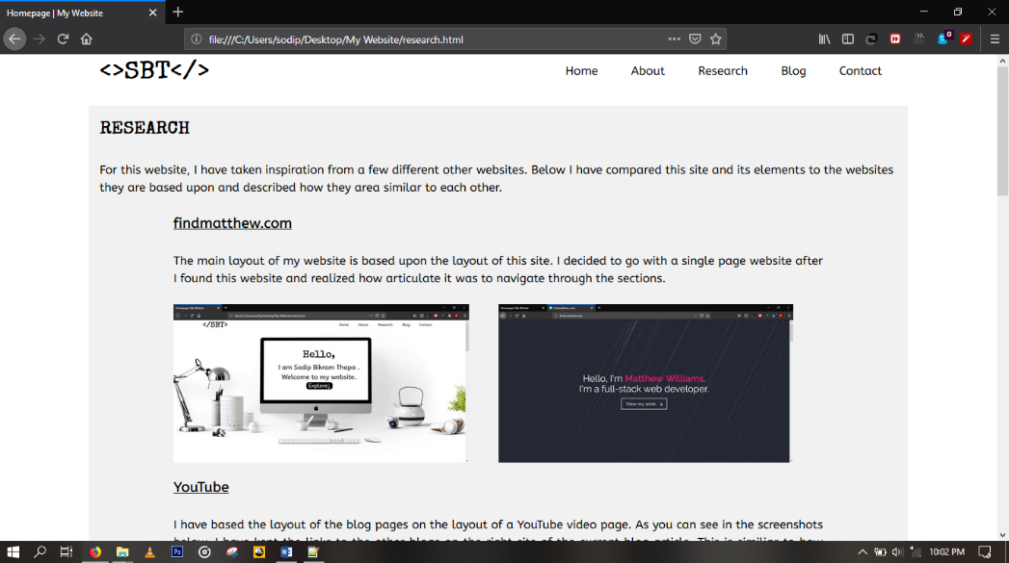

Figure 22: Test 5

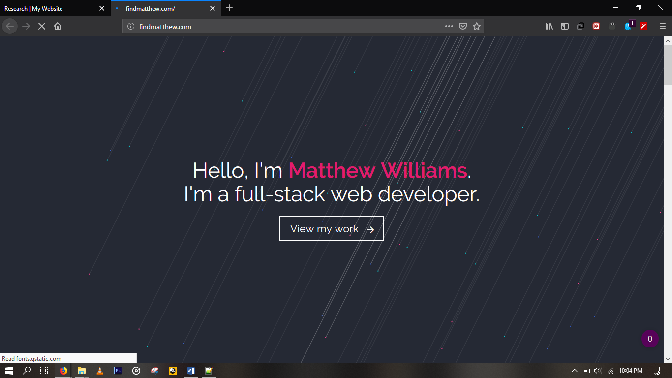

Figure 23: Test 5

# Conclusion

This project has met all the requirements and objectives of the coursework. All the research and analysis done in the completion of this project have been properly documented as per the given instructions. The research portion of the documentation has been included in the website itself while the rest of it is in this report.

Before starting to work on this project, I had no experience in making a proper website. I had previously made only one basic website during my time in high school, that also without the proper use of CSS and no use of JavaScript. Now I have a clear understanding of CSS and its use in making websites attractive. I also have understood the fundamentals of JavaScript and its significance in web development. In addition, because of researching for this coursework, I have even become familiar with the current trends of modern web development. Working on this project also gave me an opportunity to understand how a website are made in real life and how one can plan and implement their ideas for their website. I even plan to make the website that I have developed for this coursework responsive and dynamic during the holidays.

In conclusion, working on this project was a significant learning experience for me. It helped me become familiar with the dynamics of web development especially on the frontend side. My goal for the future is to become a full stack web developer and this coursework has helped me take a big step towards my goal.

# References

w3schools.com. (2019) *w3school.com* [Online]. Available from: <https://www.w3schools.com/js/default.asp> [Accessed 8 May 2019].

w3schools.com. (2019) *w3schools.com* [Online]. Available from: <https://www.w3schools.com/css/default.asp> [Accessed 8 May 2019].

w3schools. (2019) *w3schools.com* [Online]. Available from: <https://www.w3schools.com/html/html_intro.asp> [Accessed 8 May 2019].